Checklist for Attachments

We require all attachments as PDF documents to ensure proper
formatting and readability during our review process.
For instructions on how to convert Word documents
or Excel spreadsheets to PDF files, click here.

• Previous Fiscal Year Organization Budget: Organizational budget versus actuals,
including revenue and expenses

• Previous Fiscal Year Statement of Financial Position (Balance Sheet)

• Current Fiscal Year Organization Budget: Organizational budget versus actuals,
including revenue and expenses

• Year-To-Date Statement of Financial Position (Balance Sheet)

• Year-To-Date Statement of Activities (Income Statement)

• Next Fiscal Year Organization Budget: Organizational projected or proposed
budget, including revenues and expenses, if available (A draft is acceptable, but
please note if it has not yet been approved by the Board of Directors.)

• Current Fiscal Year Organization Funding Sources: All Organization Funding Sources
for this funding request (foundations, corporations, governments, etc.), including
Amount, Source and Status (received, pending or committed)
• Audit: If your organization has an audit, provide the most recent copy

• 990: Provide a copy of your most recent Form 990

• Organizational Chart
• Staff Biographies: Short biographies of staff and volunteers essential to the success of
this request
• Board List: List of Board Members, Terms and Affiliations

• Memoranda of Understanding (MOU): An example of a current MOU or Memoranda
of Agreement with other organizations for each distinct collaborative or cooperative
set of activities, if applicable

• Additional Support Documents: Any additional documents not already listed,
including budget narratives, recent letters of support from partner organizations or
other materials, as appropriate

If you are requesting project support, please include the following additional documents:
• Previous Fiscal Year or 12-Month Project Period Project Budget: Project budget versus
actuals, including revenue and expenses
• Current Fiscal Year or 12-Month Project Period Project Budget: Project budget versus
actuals, including revenue and expenses
• Next Fiscal Year or 12-Month Project Period Project Budget: Project projected
or proposed budget, including revenues and expenses, if available (A draft is
acceptable, but please note if it has not yet been approved by the Board of
Directors)

• Project Funding Sources: All Project Funding Sources for this funding request
(e.g., foundations, corporations, government, etc.), including Amount, Source and
Status (received, pending or committed)

Uploading Attachments
- Choose which attachment you are uploading from the drop down menu:
  - * EACH Required attachment must be selected and uploaded separately in order to submit your full grant application*
    - If you are unable to submit a Required attachment, please upload a document stating the reason in its place
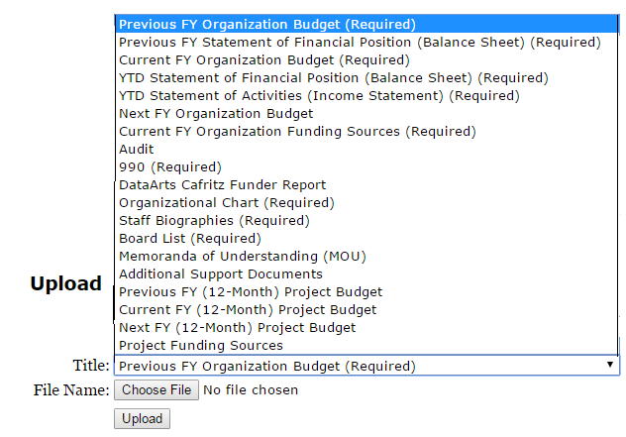
- Choose the Corresponding file (on your computer)
