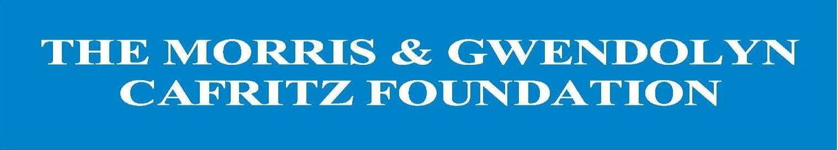

The narrative section of the application will generally run 8-10
pages in length, double-spaced with 12-point font and 1-inch margins.
This does not include the required attachments.
Note: The online application has individual text boxes that coincide with the numbered questions below.

Organization Narrative

- Describe your organization’s history and mission. Include significant milestones and key accomplishments.

- Describe your organization’s current activities, projects or programs.

- Describe the results achieved during the past twelve months.

- Describe the results you are committed to achieving during the grant period and how you will demonstrate your success. Share qualitative and/or quantitative information.

- Describe the results you are hoping to achieve over the next three years.

- Describe your organization’s most significant collaborations and partnerships with other organizations in the same field and geographic area.

- What makes your organization different from other groups doing similar work?

- Explain how the population you serve is involved in the work of the organization, and/or how client feedback is collected and incorporated.

- Briefly describe the Board of Director’s role in relation to leadership and staff, including how members are recruited and selected and how they carry out their responsibility for financial and programmatic oversight and fundraising. Indicate the percentage of directors who make monetary contributions.

- Describe any significant staff or Board changes that have occurred within the past twelve months or are expected to take place in the coming year.

If this application is for general operating support, do not submit a project narrative.
The project narrative is part of the approximately 8-10 page total.
Note: Project Requests do not include Capital Requests. If you have a capital project, please contact the Foundation for advice.

Project Narrative

- What problem/need does this project address?

- What is your organization’s proposed solution to this problem/need, and how will it be implemented?

- What evidence will prove the success of this project?

- What results are you committed to achieving during the grant period?

- Is this a new project? If so, how was the approach developed and why? If not, what has been accomplished so far?

- If this project extends beyond the grant period, what is the timeline for the entire project?

- Are there partners that are working with you on this project? If so, who are they, why did your organization choose to work with them and what are their roles? What is your organization’s unique contribution?

